**العرباوى المجيد عبد طلعت مجدى أحمد :الاسم**

**GROUP NO. : 1**

**SECTION: 5**

**TOPIC: ARTIFICIAL INTELLIGENCE**

**Github link: https://github.com/Ahmed-Magdy-Talaat/html-project-AI**

**Index:**

1. .screenshots of source code

2 .Photos of website

**Screenshots of source code:**

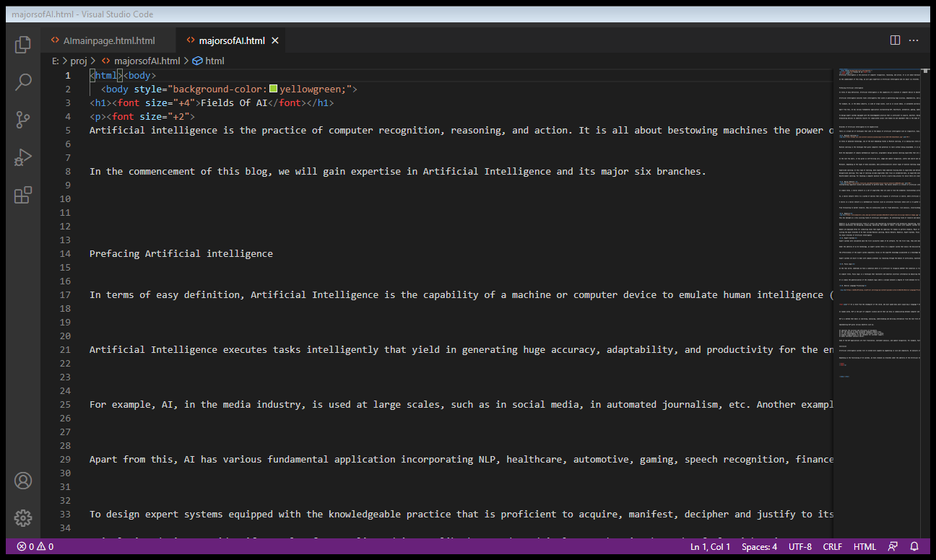

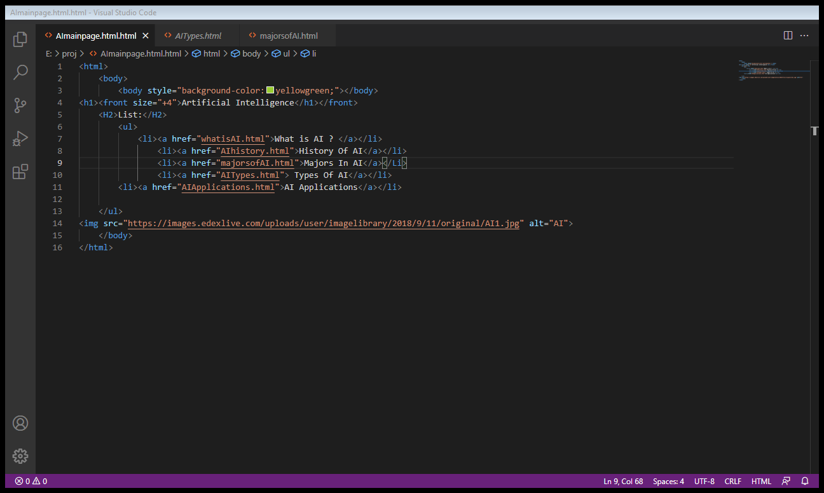

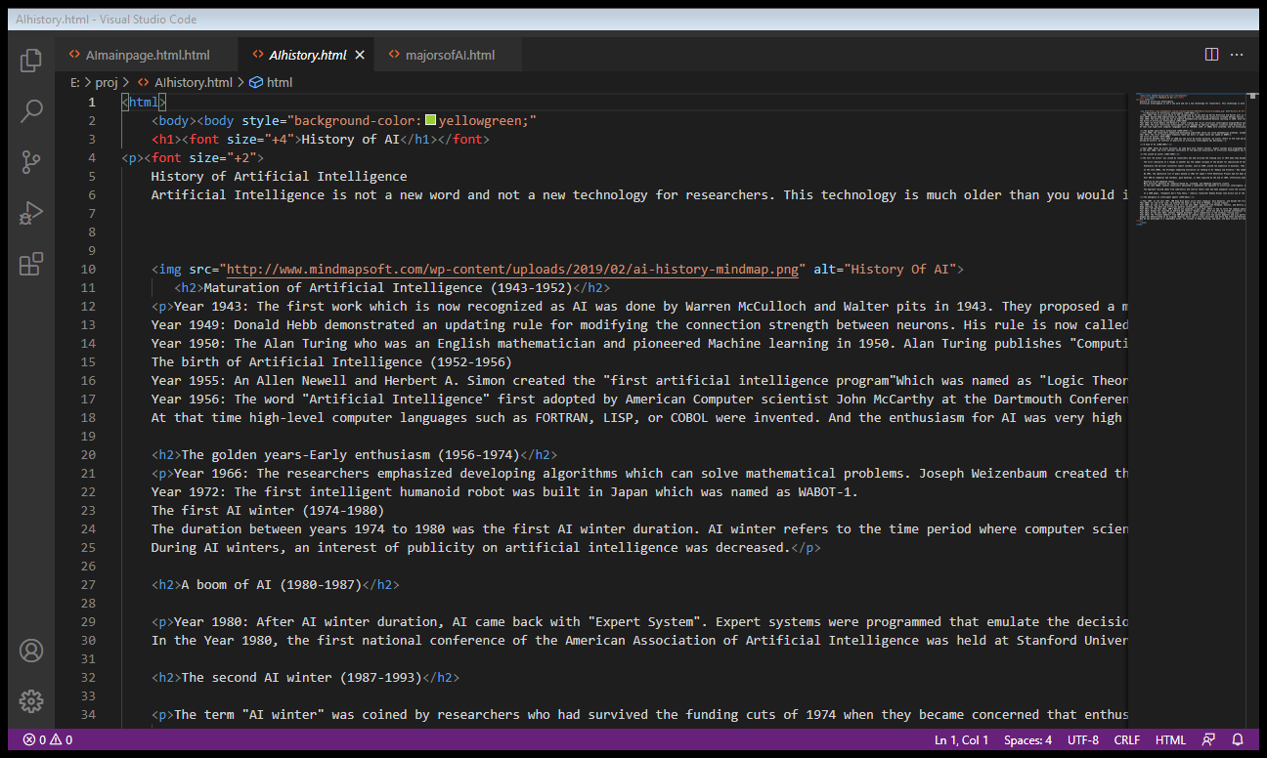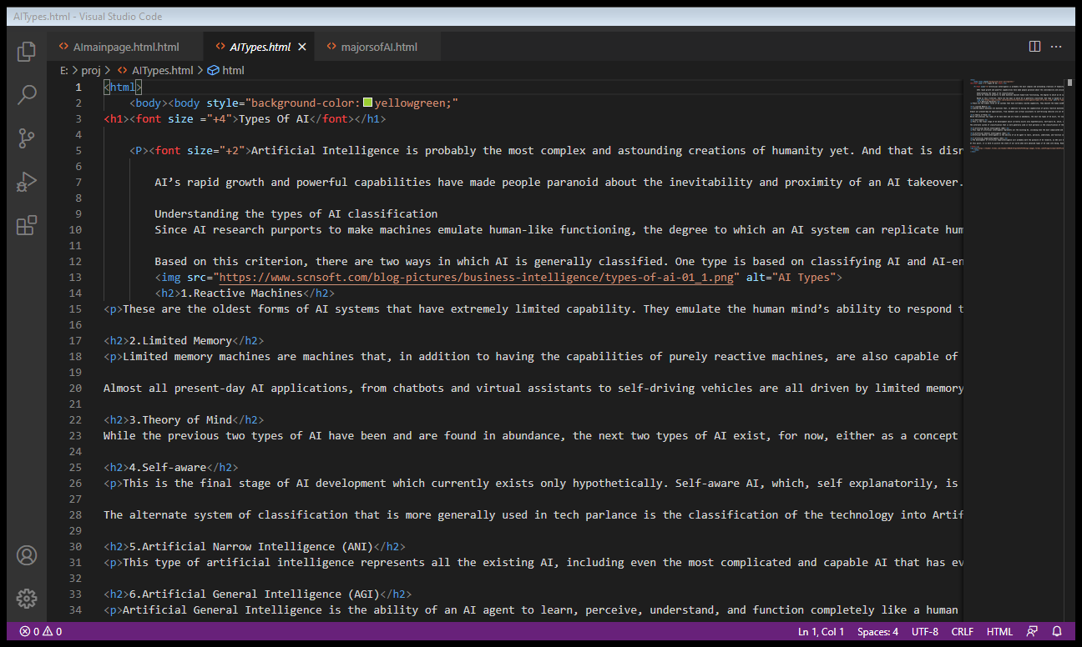

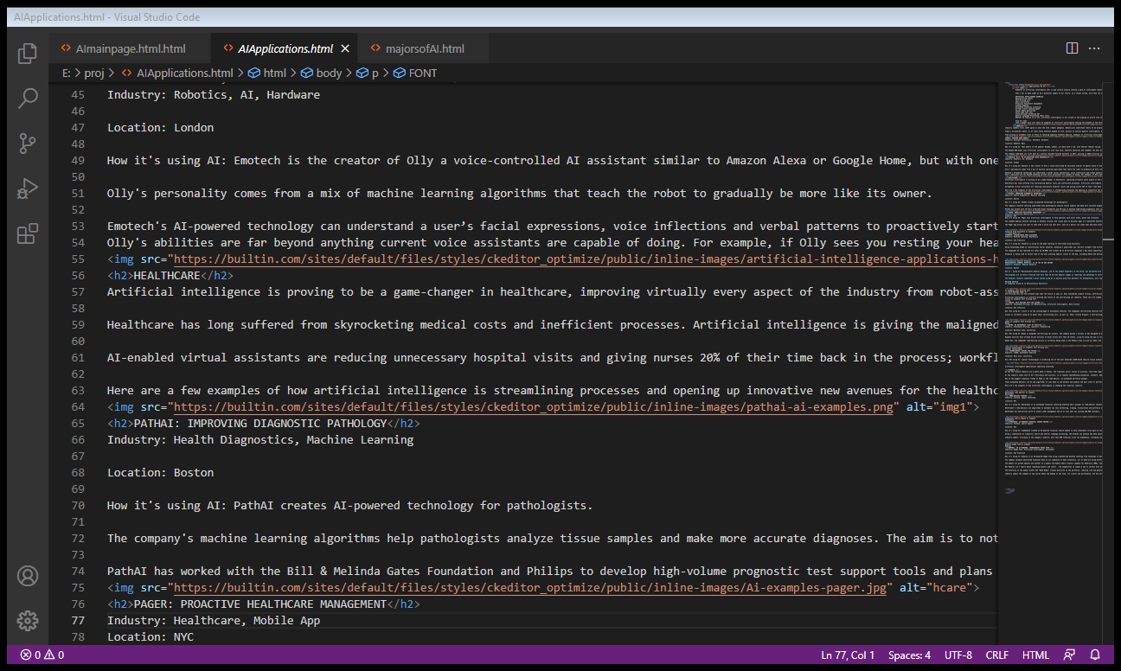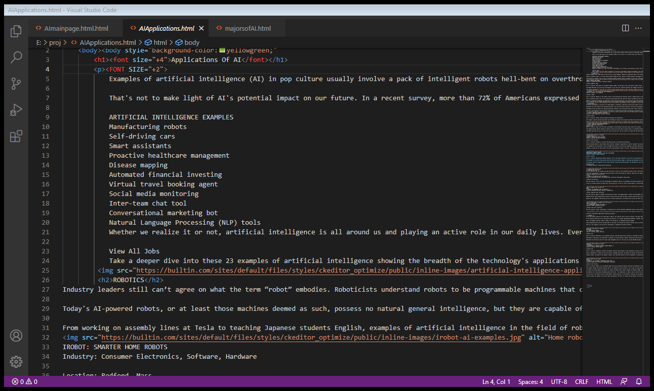

**Photos Of website:**



